ELECTROMAGNETIC RADIATION EFFECTS ON ELECTRONIC PARTICLES TRANSFER IN DNA – APPLICATIONS TO MILLIMETER AND OPTICAL RANGES

Gérard DUBOST
Institut d’Electronique et de Télécommunications de Rennes
UMR CNRS 6164, Université de Rennes 1,
Avenue du Général Leclerc, Campus de Beaulieu, 35042 – Rennes Cedex – France

André BELLOSSI

ABSTRACT

We justify the validity of the biexponential Debye relaxation model of the pure water extrapolated until the optical range by means of experiments results obtained on the human skin. The pure water attenuation per wavelength is maximum in the millimeter-wave range. We confirm the measurements which have shown appreciable A.C. conductivity of DNA due to relaxation losses of their surrounding water dipoles. We extend this property to the UV range showing the action of photons upon free electrons. Excited ions, by means of our external plasma device generator of solitary-waves is the object of photon emissions in the optical range. In particular in UV range the free electron alone is liable to be propeled by a photon with a kinetic energy with a some idea of the size to 10⁻²³ Joules. In a large range untel millimeter waves, the excited ions can attract electrons showing a kinetic energyfof 10⁻²¹ Joules. They can be used to activate control and explain the division of fibroblasts and the cancer mechanisms of human skin, the main modification of DNA molecules by UV radiation being the formation of pyrimidine dimers. Finally we can conclude that the molecule of DNA has a conducting which is always increasing with the frequency, but can be considered as a real conductor only in the millimeter-wave range with an important absorption per wavelength. The “conduction quality” is the ratio of the conduction to the displacement currents.

INTRODUCTION

PRELIMINARY CLARIFICATION

The electronic conduction in DNA is a polemic subject always going on nowadays. Is DNA conductive or not ? DNA has been reported to be a metal, a semiconductor, an insulator and even a proximity effect induced superconductor. Above all it was advisable to go back to some reminders. In a recent paper [1] it as been shown that appreciable A.C. conductivity of DNA, measured in the millimeter wave range, is largely ascribed to relaxational losses of the surrounding water dipoles. So it was necessary from the theoretical complex dielectric constant of bulk pure water, described by a biexponential Debye relaxation model [2], to calculate its conductivity , and the coefficient of absorption A given by the classical expression :

is the thickness penetration and the free space wavelength.
We introduced the “conduction quality” which is the ratio of the conduction to the displacement currents equal to : (2)
The Table I shows the various parameters in terms of the frequency for the pure water at 20 °C. We can conclude :

- The conductivity is increasing with the frequency.
- The absorption coefficient has a maximum in the millimeter range (N means Nepers : 1N = 8.69 dB).
- The absorption per unit of length (dB/mm) is increasing with the frequency.
- In the millimeter wave range the water can be considered as a “conductive medium” (>1), and as an insulator medium (<1) when f < 2.10¹⁰ Hz or f > 2.10¹¹ Hz. Nevertheless its conductivity is always increasing with the frequency.
- We can justify the values of the conductivity and the absorption in the U.V. range deduced from the experiments realized on the epidermis. The epidermis is composed, from the skin surface to the depth, by the stratum corneum, the stratum granulosum, the stratum spinosum and the stratum basale. Due to the water content of the cells we can put together the three later layers ; we call them mucus body.

The Table II shows the values extracted from measurements upon the human skin which must be compared with these given in Table I.
The range UV is separated into two ranges : UVA and UVB. For each of them, and from the measured transmission coefficient [18], we deduced the conductivity and the absorption related to the stratum corneum and the mucus body. We note that the bulk water theoretical conductivity is comprised between those of the stratum corneum and mucus body.

f(Hz) |  | (2) |  | (1) |  |  | (1) | A(dB/mm)
 | 300 mm | 0.05 | 0.22 | 0.21 m | 0.11 | 80.0 | 1.4 | 0.04
 | 60 mm | 0.25 | 5.2 | 9 mm | 0.11 | 75.2 | 6.7 | 0.97
 | 30 mm | 0.49 | 17.3 | 2.5 mm | 0.12 | 63.6 | 12.0 | 3.5
2. | 15 mm | 0.93 | 41.6 | 0.9 mm | 0.145 | 40.2 | 17.1 | 9.9
5. | 6 mm | 1.72 | 68.7 | 360 µm | 0.22 | 14.4 | 16.7 | 24
7. | 4.3 mm | 1.85 | 73.3 | 290 µm | 0.25 | 10.2 | 14.9 | 30
 | 3.0 mm | 1.79 | 76.5 | 250 µm | 0.29 | 7.7 | 12.0 | 35
5. | 600 µm | 0.74 | 99.7 | 125 µm | 0.43 | 4.9 | 4.8 | 70
 | 300 µm | 0.54 | 131 | 86 µm | 0.47 | 4.2 | 3.5 | 100
5. | 60 µm | 0.18 | 172 | 57 µm | 0.54 | 3.4 | 1.06 | 150
 | 30 µm | 0.10 | 176 | 38 µm | 0.55 | 3.3 | 0.80 | 230
 | 3 µm |  | 177 | 38 µm | 0.55 | 3.3 | 0.08 | 230
 | 0.3 µm |  | 177 | 38 µm | 0.55 | 3.3 | 0.008 | 230

Table I : Electrical parameters of pure bulk water at 20 °C in terms of frequency

Range  (µm) |  | Mean Transmission T [18] | (dB) | (dB) | A(dB/mm)
UVA  (0.315 – 0.390) | 0.352 | 4.6 %  - 13.4 dB | -9 |  | 529 | 588 | SC
UVA  (0.315 – 0.390) | 0.352 | 4.6 %  - 13.4 dB |  | -4.4 | 67 | 74 | MB
UVB  (0.280 – 0.315) | 0.298 | 0.9 %  - 20 dB | -14 |  | 823 | 914 | SC
UVB  (0.280 – 0.315) | 0.298 | 0.9 %  - 20 dB |  | -6 | 92 | 102 | MB
UV  (0.280 – 0.390) | 0.335 | 3.5 %  - 14.6 dB | -10 |  | 588 | 653 | SC
UV  (0.280 – 0.390) | 0.335 | 3.5 %  - 14.6 dB |  | -4.6 | 70 | 78 | MB

Table II (valid for

SC : Stratum corneum : thickness : 17 µm Transmission :
MB : Mucus body thickness : 65 µm Transmission :
With : T =

CHARGE TRANSPORT IN SYNTHETIC DNA

The denaturation of the DNA is due to the breaking of the hydrogen bonds, which keep in position the two strands (fig. 1).
In the course of the DNA duplication, two complementary strands give birth to two new DNA molecules. The DNA macromolecule structure was introduced in 1953 by Watson and Crick.

Electronic transport along DNA is crucial for the repair mechanism after radiation damage and biosynthesis [3]. In 1989 Peyrard-Bishop study the structure by means of global energies expressed with a Lagrangian.
The various parameters used are :
- the relative displacements of the nucleotidic bases at different sites of each DNA strand,
- the equivalent mass m of a nucleotide pair equal to 300 amu (m = 5.10⁻²⁵ Kg),
- the Morse potential which is the energy of a hydrogen bond between a pair of nucleotides,
- the average of the energy values for the guanine-cytosine basis (G-C) and for the thymine-adenine basis (A-T), which is called the well depth or Morse depth. It corresponds to the dissociation energy of a base pair and is equal do D = 0.04 eV let us be 0.64 10⁻²⁰ J,
- the width of the well equal to : w = 0.224 Å,
- the stacking energy between neighboring bonds,
- the energy of the dipole-dipole interaction,
- the dipole parameter expressed in terms of electric charge transfer and of the distance between neighboring base pairs,
- the potential energy between two consecutives bases along a strand V_{o} = 0.1eV in an equilibrum state,
- the linear frequency of the isolated oscillator which is equal to :
Hertz (3)
One considers the radial displacement of the base unit and the angular rotation between two adjacent base pairs from their equilibrium state. The lattice oscillations are designed by pulsation for the radial displacement and for the twist one.

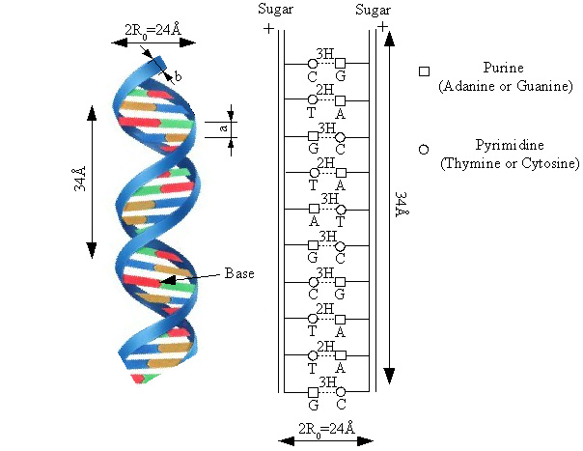

Fig. 1.

The adiabaticity parameter (4) equal to : 0.041 proves the adiabatic right hypothesis during a quasi instantaneous displacements. From the fixed parameters at an equilibrium state : a = 3.4 Å, , Å, we deduced the distance between two consecutive bases along a strand :
Å
The potential energy is equal to :
(5)
where is the moment of the charge. With we deduced : . Taking Å, gives : which is approximately the electron charge. The mobility of the charge is possible in the presence of random parametrical and structural disorders inherent to DNA molecules [3].
Recently some authors [4] have considered the charge q when hydrogen bonds stretch using quantum chemical methods taking into account the nucleoside pairs (sugar linked to base). The value of the dipole parameter (6) is equal to : Å² let us be 0.053 with q = - 0.095 e,
which is the charge transfer intermediate between the A-T and G-C base pairs [1].
The stacking parameter is given by some authors [5] equal to 0.96 J/m² (let us be 0.06 eV/ Å²), and by others [6] comprised between 0.01 and 10 eV/ Å². It has been then considered as adjustable parameter [4]. In short we can report according [4] that solitons or “discrete breathers” can be also generated from or exist among random thermal fluctuations. Moving breathers with speed comprised between 4 and 24 m/s, behave as quasiparticles, having an effective mass between 30 and 46 amu and a kinetic energy comprised between and which is able to pass over a bending point in function of the strand curvature. For T = 310° K the thermal energy is or . The conduction mechanism in DNA was recently studied [7], showing the impact of disorder. Evidently the charge motion is influenced by the vibrational modes of the double helix. Results concerning the electron transport in synthetic DNA polymers had been recently published [8]. For many organs we know that beyond a frequency of Hertz, the conductivity trends upward very quickly [Gabriel King’s College, London, June 1996]. To establish the theory of the cell division Popp [8] supposed a high conductivity for the cell membrane without indication of its value. Albrecht-Buehler [9] thinks that centriolar “blades” have a high conductivity. Centrosome is an intracellular organelle composed of 2 centrioles and pericentriolar material. The centrioles are a pair of cylinder-like structures. (0.8 0.15 µm) often disposed in an orthogonal way to each other. Each centriole is composed of 9 separate protofilaments (0.8 µm 40 nm). Electrons of very low energies can induce substantial yields of single and double strand breaks of DNA in near infrared spectrum [10] and [11]. To be in a good agreement with numerous experimental results in near infrared, visible and near ultraviolet spectra we must choose a conductivity of for the membrane medium [12].

The figure 2 gives the theoretical velocity v of the moving electron along the DNA chain, as a function of the amplitude of the periodic field parallel to the double helix axis, for different frequencies in the millimeter wave ranges. It is taken out from [3] but expressed now with more convenient parameters. The normalized frequency given in [4] is related to the frequency (3), with D = 0.04 eV, w= 0.224Å and Coherent electron transfer can be stimulated when the frequency of the applied field is such that : .To be efficient the applied external electric energy has to be higher than let us be :Å that is V/m.

Moreover the electron kinetic energy comprised between and , is very weak compared with the thermal fluctuation kT.

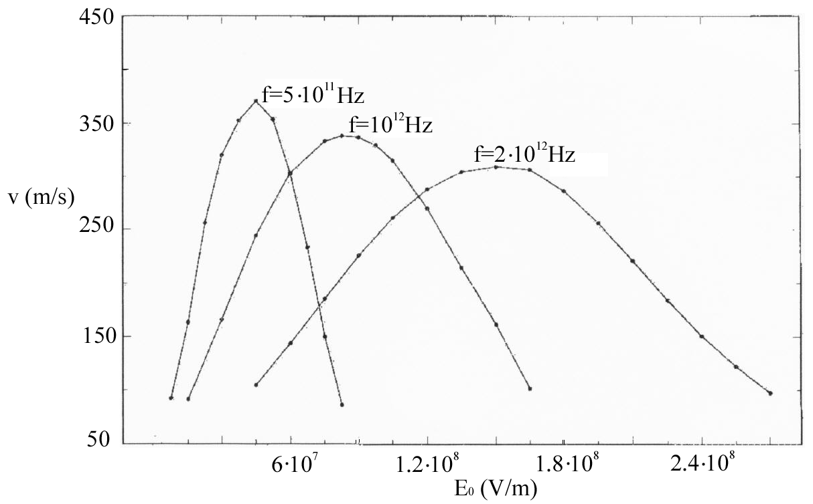

Fig. 2

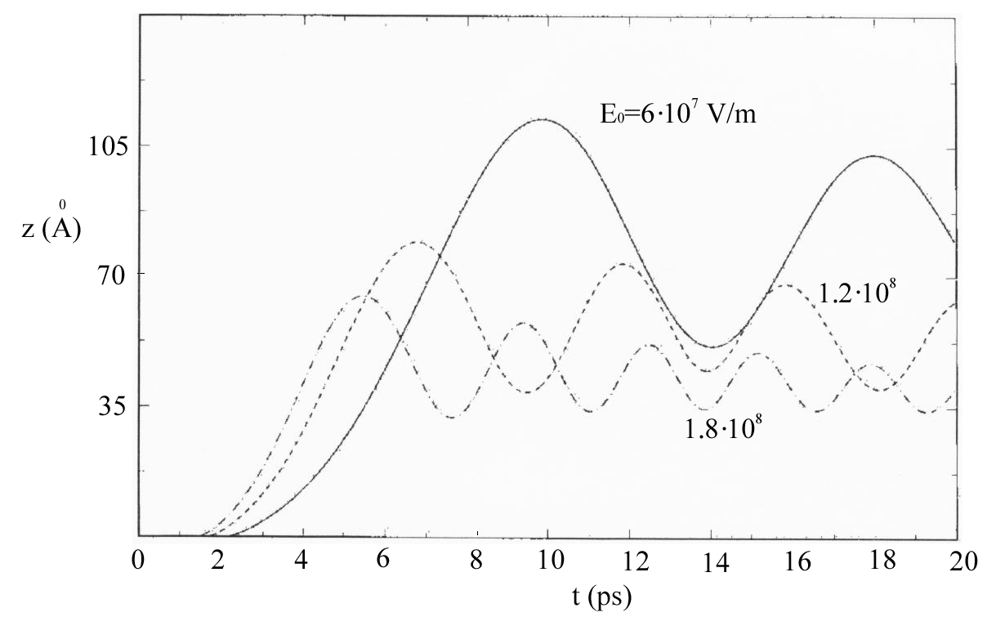

Fig. 3 : Temporal electronic occupation probability

The figure 3 shows the temporal behavior of the electronic occupation probability of the electron along the DNA axis in the presence of the external field at Hz for different amplitudes and a disorder of 0.02 eV. The position corresponds to the electronic occupation probability after a propagation from a starting one for t = 0. When the field amplitude is enlarged the dynamic of the electron and the amplitude of the oscillations become weaker. The oscillation frequencies f_{osc} are higher than the electronic one equal to as indicated in Table III.

Table III (valid for )

Whatever , the maximum velocity at is equal to . All these results, valid for a relative strong disorder on site electronic energy equal to 0.02 eV, are due to the nonlinear physics applied to DNA.

COMPARISON BETWEEN THEORY AND EXPERIMENTS IN MILLIMETER RANGE

A.C. conducting DNA in the millimeter range has been measured. Several authors have shown an appreciable conducting which approaches that of a well-doped semiconductor. Nevertheless it has been found that the high A.C. conductivity of DNA can be attributed largely to relaxational losses of the dipoles of the water molecules in surrounding hydratation layers [1]. The total number of water molecules per nucleotide has to be correlated with the relative humidity [13]. For instance the adsorption of water molecules per nucleotide is equal to 13 for a rate of humidity (R.H) equal to 84 % and 4 for a R.H of 60 %. For an R.H of 0 %, there are 2.5-3 water molecules per nucleotide which cannot be removed from the helix. The table IV shows the A.C conductivity of calf thymus DNA measured in terms of the frequency [1].

f(Hz)
RH : 0 % [1] | 1 | 12 | 35 | 100
 | 25  4.9  0.60 | 50  5.4  0.75 | 70  3.5  0.40 | 110  3.0  0.50

Table IV : conductivity σ measurements of calf thymus DNA

The conductivity, which is increasing with the frequency and the rate of humidity, can be atrributed largely to the water layer surrounding the DNA blackbone. In effect, for a R.H equal to 84 % the absorption A() and were calculated with the relations (1) and (2) using the experimental conducting [1] and given in Table I. The experimental values [1] and the deduced absorption A shown in Table IV are normally as should be weaker than these shown in Table I valid for the bulk pure water. The measured conductivities of the single and double strands have been found identical [1]. Considering the weak values of we can say that the DNA can be reported to a dielectric medium in spite of its important conductivity. Previously reported conductivity value of 240 S/m was evaluated from the measured loss of highly sensitive resonant cavities operating at 12 and 100 GHz [14].

SOLITARY-WAVE EMISSIONS

The emission are due to solitary-waves or solitons issued from an external confined plasma device [15]. The induced emission lifetime of the ion in vivo medium is given [17] :

(7)

is the mean complex, index of refraction at in the vivo medium.
The parameters inserted between brackets are related to the plasma device.
is the electric moment of the dipolar transition. Z is the atomic number of the ion. is the square signal modulation frequency of a high RF frequency used to light the discharge inside the plasma tube. The density of the ions at the fundamental state in a strong electrolyte, equivalent to the interstitial liquid, which has been carried is equal to : : [16].
From [17] we deduced in the vivo medium :

(8) (9)

is the density of excited ions per unit of volume andthe frequency of their photonic emission. From we deduced the mean distance between sollicitaded ions by the expression : (10)
We showed that a low frequency acting upon ion produce an ionizing radiation in the optical range [17].
The Table V shows the calculated values related to the ion induced emissions in terms of the free wavelengths for a higher modulation frequency and a weak lifetime.

 | 0.25 µm | 1µm | 10 µm | 100 µm | 1 µm | 1.78 µm
d | 16 µm | 4 µm | 0.4 µm | 400 | 40 | 22
 |  |  |  |  |  | 0.5
 | 64 | 4 | 0.04

Table V : Ion induced emission

valid for (9), ,

When the wavelength is enlarged the mean distance d between the sollicited ions and the energy of the quantic oscillator W are decreasing, while their density increases. We have shown in [17] that when two adjacent dipoles have a strong mutual coupling such that the radiation of the array due to the whole excited ions was suppressed. Nevertheless the electric field amplitude due to one ion is given by :

(11)

is the electric moment of the dipolar transition approximately equal to :

Å=1.6 (C.m)

For r = 10Å, we obtain from (11) : . Let us consider the electrostatic attraction of an electron by the ion when the viscosity strength is taken into account. We calculate for r = 10 a speed of that is a kinetic energy equal to eV. Let be a free electron motionless knocked by a photon of energy. We suppose a perfectly elastic shock. Before and after the shock the whole impulse is unchanged. If we neglect the compton effect, that is the frequency variation of the photon, we can write :

(12),
With : we deduced from (12) the electron speed : . So the electron kinetic energy is equal to : J, that is The photon which is associated with an electromagnetic wave is moving along the DNA with a speed equal to : (see Table I). The photon can be also absorbed by the particle. Then the photo-ionization principle may give birth to an electron, with an energy higher than .

SUMMARY

a) We introduced the ratio of the conduction to the displacement currents to express the conduction quality (2) of a medium. Thus the pure water has a conduction which is always increasing all along the frequency range, while the conduction quality is the highest in the millimeter wave range (Table I).

b) We justify the validity of the biexponential Debye relaxation model of the pure water extrapolated until the U.V range, by means of experiment results obtained on the human skin.
c) Table I shows the attenuation per wavelength which is maximum in the millimeter-wave range. Recent measurements in that range have shown appreciable A.C. conductivity of DNA which is largely ascribed to relaxational losses of the surrounding water dipoles [1]. We have extended this property to the UV range (Table II), showing further the action of photons upon free electrons.
d) Excited ions, by means of our external plasma device generator of solitary waves, is the object of photon emissions where an example is given in the Table V. An electron can be shocked by a photon in UV, showing a kinetic energy equal to eV. What’s more by means of the electrostatic attraction of one ion, an electron can show a kinetic energy equal to eV. They can be used to activate, control and explain the division of fibroblasts and the cancer mechanisms of human skin, the main modification of DNA molecules by U.V radiation being the formation of pyrimidine dimers [11].

REFERENCES

[1] M. BRIMAN, N.P. ARMITAGE et all, Dipole relaxation losses in DNA. Depart. of Physics and Astronomy, University of California, Los Angeles, CA 90095, 8 Nov. 2005.
[2] C. RONNE et al, J. Chem. Phys. 107, 5319 (1997).
[3] D. HENNING, J.F.R. ARCHILLA , Polaromic charge transport mecanism in DNA. Elsevier Preprint, May 18, 2005.
[4] J. CUEVAS, E.B. STARICOV et all, Moving breathers in bent DNA with realistic parameters ar Xiv : nlin.PS/0404029V3,4, Nov. 2004.
[5] T. DAUXOIS, M. PEYRARD, A.R. BISHOP, Phys. Rev. E 47, 684 (1993).
[6] J. CUEVAS, J.F.R. ARCHILLA et all, Moving breathers in a DNA with competing short and long-range dispersive interactions, Physica D 163 : 106, 2002.
[7] P. CARPENA, P. BERNAOLA-GALVAN et all, Nature 418, 955 (2002).
[8] F.A. POPP, Basic theory of cancer development and defense, Intern. Conf. Biological Cancer Defense in Heidelberg, May 3-5, 2002.
[9] G. ALBERCHT BUEHLER, Altered drug resistance of microtubules in cells exposed to infrared light pulses. Cell mobility and cytoskeleton, 1998, vol. 40, pp. 183-192.
[10] A. BOUDAFFA, P. CLOUTIER et all, Resonant formation of DNA strands breaks by low energy electrons, Science 3 March, 2000, vol. 287.
[11] J. HUGO, NIGGLI, Ultra weak photon emission in differentiated fibroblasts. Conference on biophotons, 1999.
[12] G. DUBOST, A. BELLOSSI, Cell membrane physical model in near infrared, visible, and near ultraviolet spectra. Biological Effects of EMFS, 3rd Intern. Workshop Kos, Greece, 4-8 October, 2004, p. 492 to 500.
[13] S. BRAUNAUER, P. EMMETT et all, J. Am. Chem. Soc., 80, 309 (1938).
[14] K.H. YOO, D.H. HA et all, Phys. Rev. Lett. 87, 198102 (2001).
[15] G. DUBOST, A. BELLOSSI, J. BARE, Efficiency of solitary-waves radiated by the discharge in a confined plasma column. Biological Effects of EMFS, 3rd Intern. Workshop Kos, Greece, 2004, p.473 to 481.
[16] G. DUBOST, A. BELLOSSI, Electromagnetic field diffracted by a nervous fiber excited by an external electric field. Biological Effects of EMFS, 3rd Intern. Workshop Kos, Greece, 2004, p. 482 to 491.
[17] G. DUBOST, A. BELLOSSI, J. BARE, Solitary waves effects on Ions Emissions in the living matter. MMS Proceedings : MSA6, pp. 210-215, sept. 6-8, 2005, Athens, Greece.
[18] K. HOFFMANN, K. KASPAR, P. ALTMEYER, T. GAMBICHLER, UV Transmission Measurements of Small Skin Specimens with Special Quartz Cuvettes. Dermatology 2000; 201; 307-311, Ruhr University, Bochum, Germany.

